Sales Data Analysis Dashboard

Project Overview
The Sales Data Analysis Dashboard provides a complete and interactive view of the company’s sales performance across products, cities, months, and time periods. It helps stakeholders quickly understand trends, compare product performance, and track progress against sales goals.
Objective
To analyze overall sales performance and identify key insights such as:
- Best-selling products
- Monthly and city-wise sales trends
- Category-wise contribution
- Performance vs. goals
- Customer buying behavior (time-of-day analytics)

Key Components of the Dashboard

1️. Top Product Highlights
- Displays total sales for major products like MacBook Pro Laptop, iPhone, and ThinkPad Laptop.
- Helps identify top-performing products instantly.

2️. Sales by Month
- Line chart showing monthly sales trend.
- Helps monitor seasonal patterns and growth/decline in sales.

3️. Product Category by City
- Bar chart comparing different product categories (e.g., audio devices, batteries, cables).
- Useful for knowing which category sells best in each city.

4️. Sales in Month vs Goal
- KPI visual comparing current month sales with target goal.
- Shows progress with clear indicators.

5️. Sales by City
- Column chart showing city-wise total sales.
- Identifies high-performing cities and areas for improvement.

6️. Sales by Time of Day
- Pie chart showing sales contribution across Morning, Afternoon, Evening, and Night.
- Helps understand customer buying behavior.

7️. Sum of Sales by Product
- Horizontal bar chart ranking products by total revenue.
- Useful for product performance comparison.

Key Insights (Sample)
- MacBook Pro and iPhone are the highest revenue-generating products.
- Major spike in sales seen toward the end of the month.
- Peak customer purchase time is Evening.
- City A and City B generate the largest share of sales.

Tools Used
- Power BI
- DAX for KPIs and advanced measures
- Power Query (M language) for data cleaning and transformation

Conclusion
The Sales Data Analysis Dashboard provides a comprehensive view of overall sales performance by combining product-wise, city-wise, monthly, and time-based insights into one interactive platform. It helps decision-makers quickly identify top-performing products, understand customer purchasing patterns, and evaluate progress toward monthly sales goals.
By using Power BI with DAX and Power Query, the project successfully transforms raw sales data into meaningful visual insights, supporting better business decisions and strategic planning.
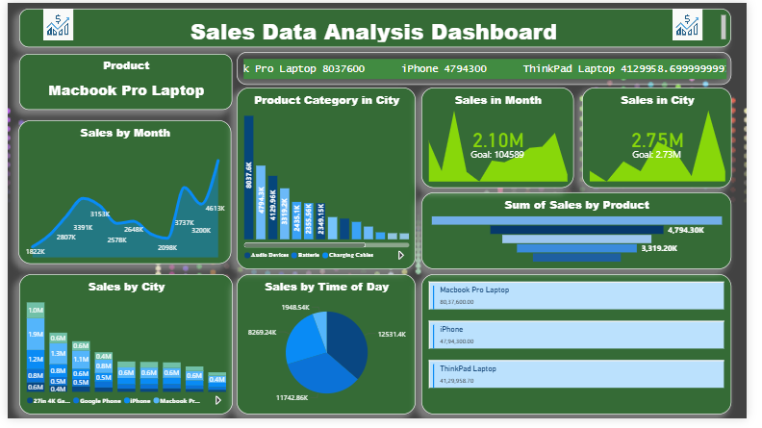
Over view:

